Deeepti Bankapur

Sensors
There are various sensors used in the InMoov robot to sense touch or motion. The use of sensors are to increase the performance and functionality of the robot, make it more aware of its surroundings and to make it more human. In turn the sensors help the robot respond to a certain situation. The following are the sensors used:

-Capacitive Touch Sensor (MPR121 Breakout Board)
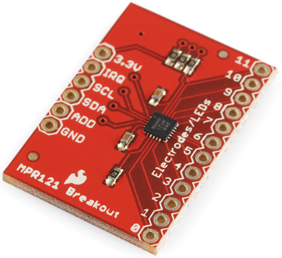
The MPR121 board can be found on this website: https://www.sparkfun.com/products/9695

This capacitive touch sensor has 12 input pins and can detect touch from a surface that is conductive. The MPR121 works by using I2C communication and measuring the capacitance between the 12 input pins. The electrodes placed are located in the robot’s head, face and jaw. Since this sensor takes the human body capacitance as its input, as ones hand comes close to or in contact with the electrode, the measured capacitance changes and lets the MPR121 know that a certain input has been touched.

Moreover, three different types of conductive material was tested to figure out which was the best. The materials tested were aluminum foil, capacitive tape and copper tape. The best results came from the copper tape and a bonus was that cables could be soldered directly onto the copper tape.

Here is a schematic of the connections between the Arduino Nano and MPR121:
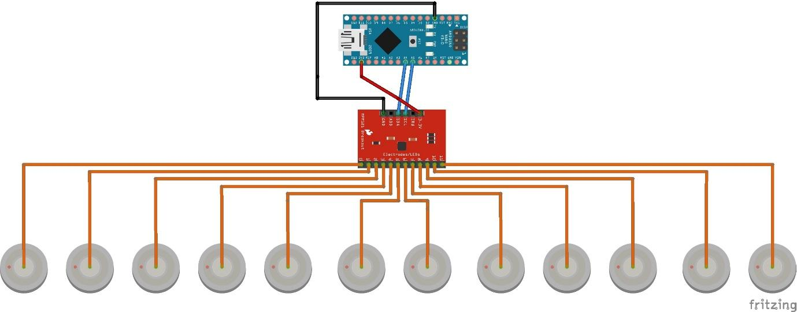
The libraries used to make the touch sensor work are the I2C and MPR121. The I2C library is used for communication between the Arduino and the MPR121 board.

Besides enabling all the electrodes and choosing the correct charge time, we added several functions to the code to be able to sense touch:
-void electrodes(): Reads the electrode values from the sensor.
-void calibrate_electrodes (int calibration_value): Saves the sensor values in an array for the calibration process and takes in a sample of 50 values.
-void average(): Uses the values from the calibration process to determine the average value of the capacitance for each input pin.
-void sensetouch(): Detects if robot head/face/jaw has been touched or not. For example, here is sample code which shows how this function works:
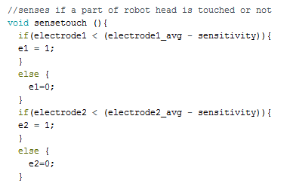
Therefore, if the calculated measurement is less than the electrodes average calibration when not touched minus a set sensitivity, then set the electrode value to 1 so that the software that the data is sent to knows that a certain part is touched and the segment can be highlighted. If not, then set it to zero and the segment will stay unlit.

-void send_data(): Values stored in the variables used in the sense touch function and separates them into string values so that it can be sent to the processing software which displays a sketch of the robots face/head and highlights which area has been touched.

-Gesture Sensor
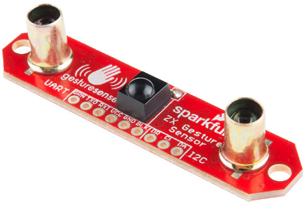
This sensor can be found here: https://www.sparkfun.com/products/12780

The gesture sensor is located in the back of the robot’s head and is used to detect motion and distance in the x and z axis.

Here is the schematic of how to connect the gesture sensor to the arduino.
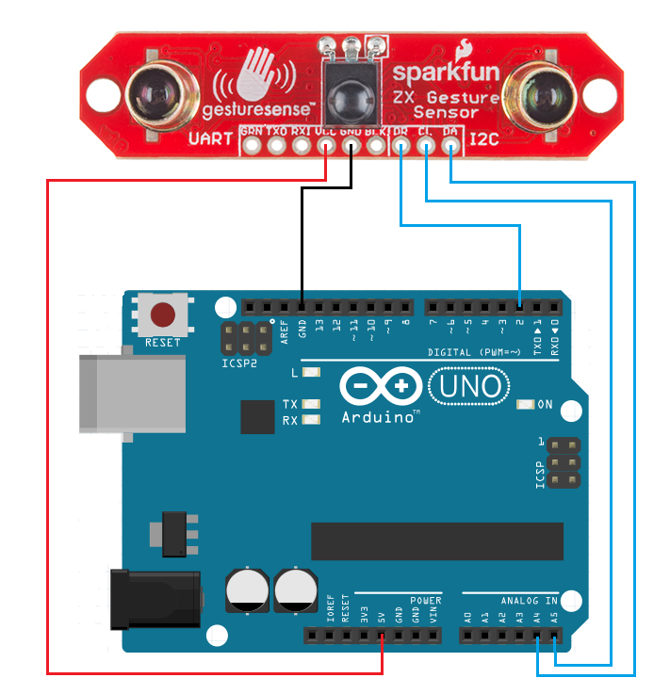

-Vibration sensor (Piezo)
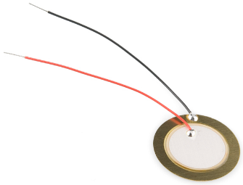
The Piezo sensor can be found here: https://www.sparkfun.com/products/10293?gclid=COjF2pauxMkCFc5bfgodnosJmg

The Piezo sensor is a vibration sensor and is placed in the head of the robot. To increase the sensitivity of the sensor, some extra weight is required. When the sensor detects vibration from a knock or a flick to the surface that it’s attached to, it generates a voltage which sends a signal to the serial monitor.

Processing Software
The benefit of using this software is that it helps visualize data for prototyping and demos. Thus, to show that the touch sensing works, a sketch of the face and robot head were created using the draw function. If a certain part of the robot’s face is touched, that area lights up in red and once the board no longer senses touch, the area is not highlighted anymore.

Here are snapshots of the data being sent to the processing software from the arduino.

Printed Circuit Board Design
Followed and modified the schematic used for the vibration sensor from the following website:
http://davidhoulding.blogspot.com/2014/02/high-sensitivity-vibration-sensor-using.html?m=1

This is how our PCB turned out:
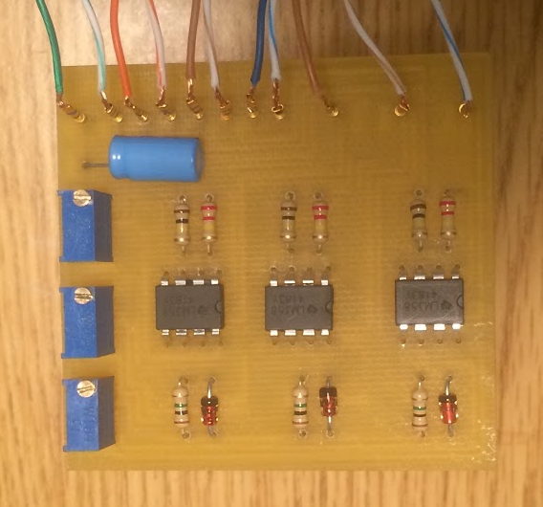

Components Used on PCB:
-1MΩ Resistor
-100kΩ Resistor
-220kΩ Resistor
-5.1V Zener Diode
-Potentiometers set to about 91kΩ
-10µF capacitor
-LM358 IC

